**NETCOMPANY – PROJECT DATA ANALYSI (PDA)**

**D0100 – USER-INTERFACE GUIDELINES**

.

.

.

.

.

.

.

.

.

.

.

.

.

.

.

.

|  |  |
| --- | --- |
| **Version:** | 1.0 |
| **Status:** | Approved |
| **Approver:** | Ngô Thái Bình  Nguyễn Thị Diễm Trang |
| **Author:** | Bui Khanh Hung |



**Document history**

|  |  |  |  |  |
| --- | --- | --- | --- | --- |
| Version | Date | Author | Status | Comments |
| 1.0 | 05-11-2020 | Bui Khanh Hung | Pending |  |
| 1.0 | 18/12/2020 | Hao Bui | Approved |  |

**References**

|  |  |  |  |
| --- | --- | --- | --- |
| Reference | Title | Author | Version |
|  |  |  |  |

**Table of contents**

**Introduction** **4**

**Target group** **4**

**Responsive design and screen resolution** **4**

**Grid** **4**

**Desktop** **5**

**Tablet** **5**

**Mobile** **5**

**Base Elements** **6**

**Links** **6**

**Text** **6**

**Font Color** **6**

**Headlines** **6**

**Icons** **7**

**Pagination** **7**

**Bullets** **7**

**Form and Input fields** **8**

Validation messages/feedback 9

**Buttons** **9**

**Radio buttons** **10**

**Check boxes** **10**

**Dropdowns** **10**

**Date fields and use of date pickers** **11**

**Custom Components** **14**

**Line Chart** **14**

**Bar Chart** **15**

**Stacked Bar Chart** **15**

**Pie Chart** **16**

**Embedded Google Map** **17**

**Banner Alert** **17**

**Contextual FAQ** **18**

**Dropdown Selection Component** **18**

**Table Component** **18**

**Browser support** **18**

# Introduction

The User-Interface Guidelines documents the styling of base elements and generic HTML parts. The document also describes the design of reusable components available in the Netcompany Crossword Puzzle (NCP) project.

## Target group

The purpose of this document is to describe and document the user interface guidelines for the solution.

The target audience is intended for developers, who are to implement the solution, as well as testers who are to test and approve the implemented solution.

# Responsive design and screen resolution

## Grid

The Netcompany Crossword Puzzle is designed upon a 12 column grid system. The grid columns will allow content creators to split the layout of pages in 7 different ways as seen in Figure 1. Backgrounds can go to the margin of the browser viewport, however they will be cut at a maximum width of 1440px.

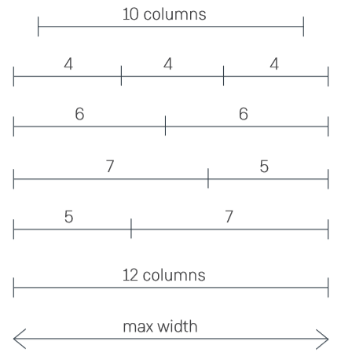

Figure 1 - Grid column combinations

s

## Desktop

Content on the puzzle game will adhere to a desktop oriented layout once the browser viewport exceeds a minimum width of 992px.



Figure 2 – Desktop with a viewport width of 992px or more

## Tablet

Content on the puzzle will adhere to a tablet-oriented layout once the browser viewport exceeds a minimum width of 768px and below 992px (desktop-breakpoint).



Figure 3 – Tablet in portrait orientation with a viewport width of minimum 768px and below 992px

## Mobile

Content on the puzzle game will adhere to a tablet-oriented layout once the browser viewport goes below 768px (tablet-breakpoint.



Figure 4 - Mobile in portrait orientation with a viewport width of maximum 768px

# Base Elements

The section documents the design of basic HTML elements in use through the project.

## Links

|  |  |  |
| --- | --- | --- |
|  | **Default State** | **Hover/Active State** |
| Basic link |  |  |
| Link with icon |  |  |

Figure 5 - Links at different states

## Text

All text on the project Netcompany Crossword Puzzle (NCP) will use the Gotham font.

For body text, paragraphs and buttons we will use the Gotham Rounded font.

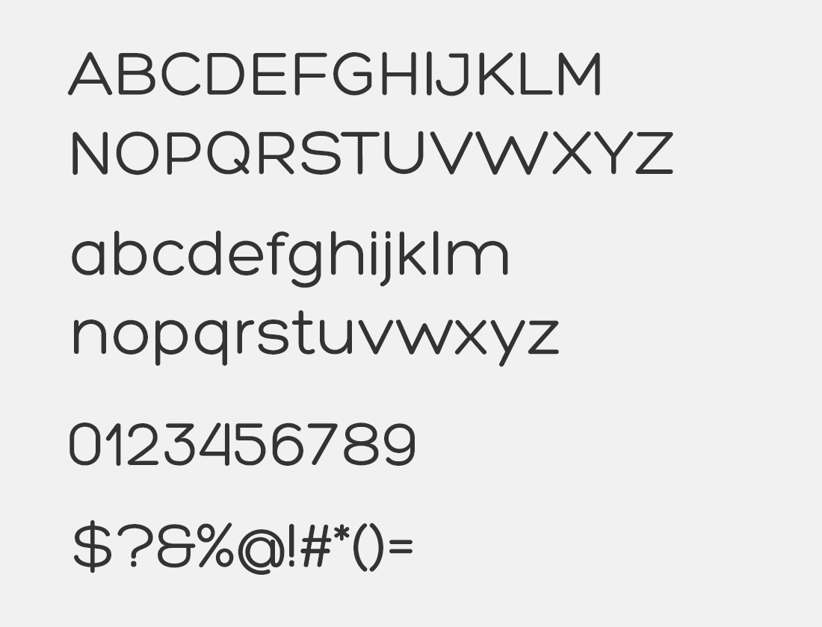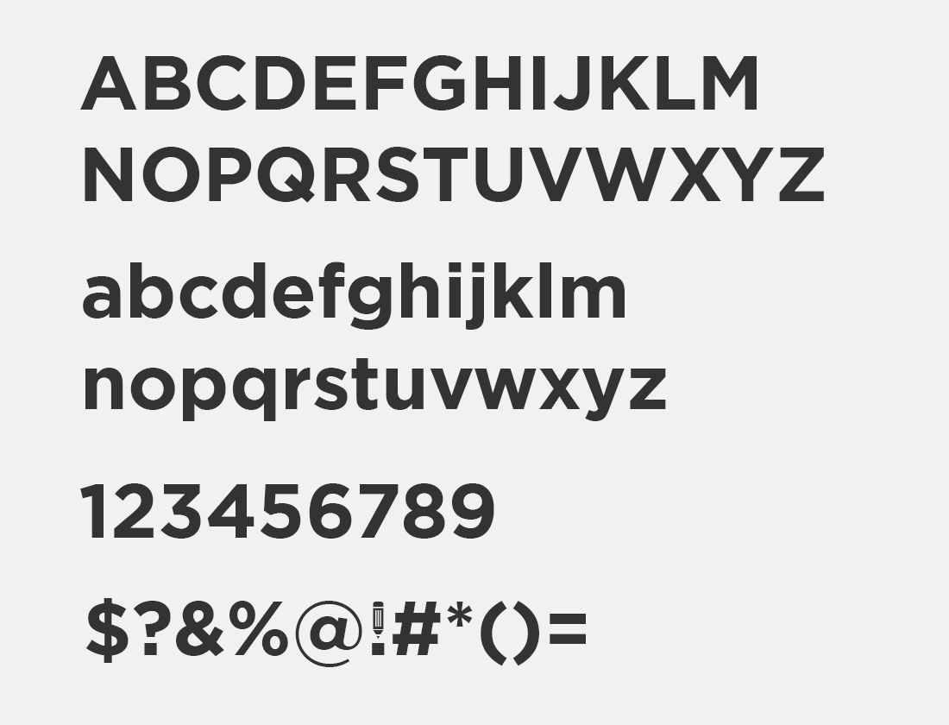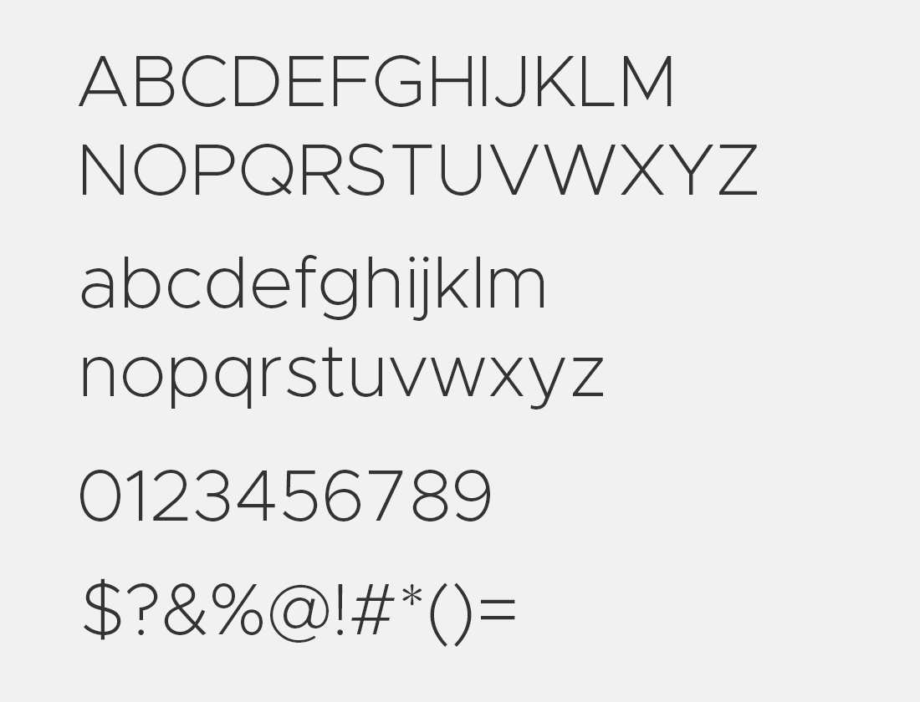

Figure 6 - Gotham Font (Gotham Rounded - Gotham Bold - Gotham Light)

When text is supposed to be highlighted in bold, the Gotham Bold will be used.

## Font Color

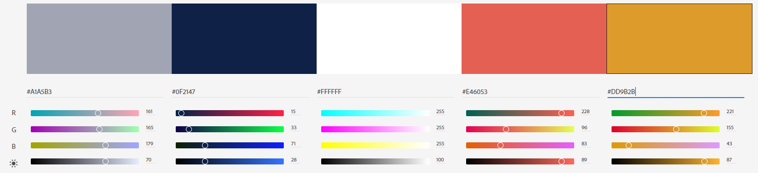

Figure 7 - Font Color

## Headlines

For all headlines on Project the Gotham Light will be used.

## Icons

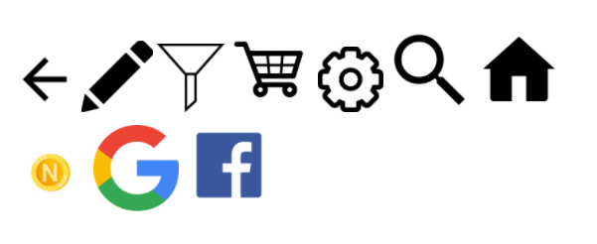

Figure 8 - Icons

## Pagination



Figure 9 - Pagination

## Bullets

In general listed information will go unbullet as seen in Figure 10.

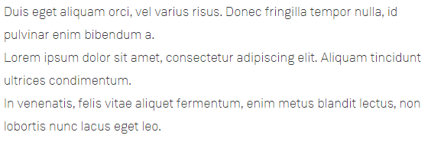

Figure 10 - Bullet list without dots

However, in the case where bullets are required, they will be displayed as dotted (unnumbered) bullet lists as seen in Figure 10.

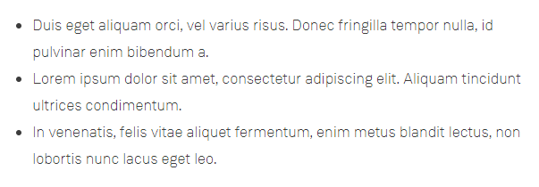

Figure 11 - Bullet list with dots

## Form and Input fields

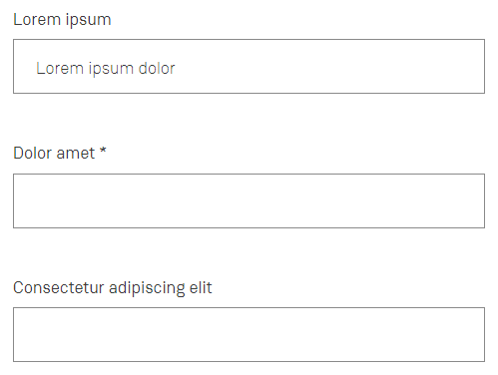

Figure 12 - Form input

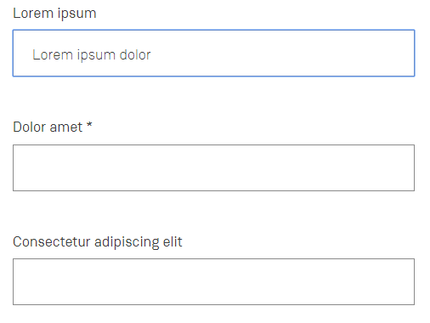

Figure 13 - Form inputs with one focused

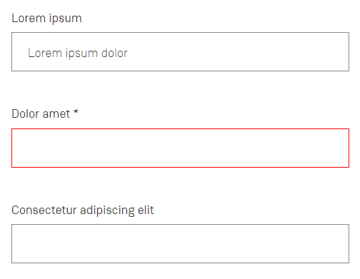

Figure 14 - Form inputs with one error validated

### Validation messages/feedback

Mandatory form inputs will be marked with an asterisk on the label for that field.

Inputs which are in focus / active, will have a blue focus colored border as seen in Figure 13.

When a form is validated and any inputs are deemed invalid, those inputs will have a red colored border as seen in Figure 14.

## Buttons

Buttons will adhere to the Netcompany main color scheme, where the primary purple colors will be used for the different button states.

As an alternate option, the secondary button can be used, which will have a white background instead.

There are two variants of buttons that can be used. A button which will have an arrow icon next to it, and a standard button without.

|  |  |  |
| --- | --- | --- |
|  | **Default State** | **Hover/Active State** |
| Primary button |  |  |
| Primary button with icon |  |  |
| Secondary button |  |  |
| Secondary button with icon |  |  |

Figure 15 - Buttons at different states

## Radio buttons



Figure 16 - Radio buttons

Radio buttons will always adhere in a group of radios, where only one radio will be selected at a time.

## Check boxes



Figure 17 – Checkboxes

Check boxes can be used in a group of checkboxes or as standard alone checkboxes, which can either be selected or unselected. When multiple checkboxes are used in a group, then more than one checkbox is allowed to be selected/checked.

## Dropdowns

|  |  |
| --- | --- |
| Dropdown Option | Dropdown Option on focus |
|  |  |

Figure 18 - Dropdown option

The dropdown option can have multiple options to choose from, however only one option can be selected at a time.

Notice that the blue focus color is determined by the desktop browser used by the client.

On mobile devices, the Dropdown Option has a different visual look since the native behavior on mobile is different. E.g. there is no mouse pointer available on touch devices, thus the available options are often displayed as a scrollable list.

Example of dropdown options is seen in Figure 19 (iOS Safari) and Figure 20 (Android Chrome). Note that this behavior and visual look is different from devices and the client browser used.

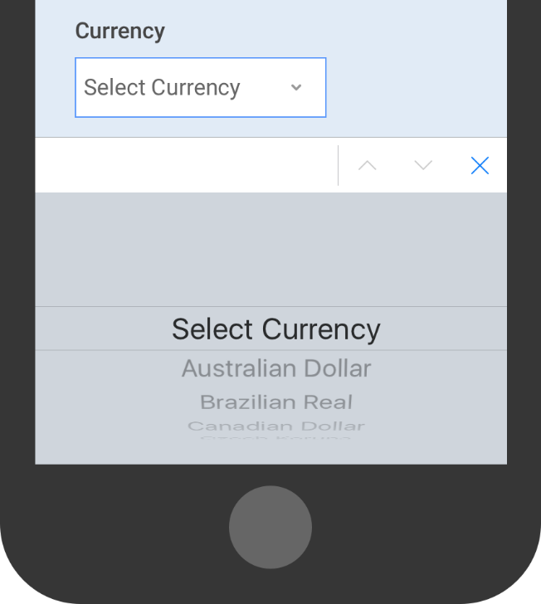

Figure 19 - iOS Safari Dropdown Option

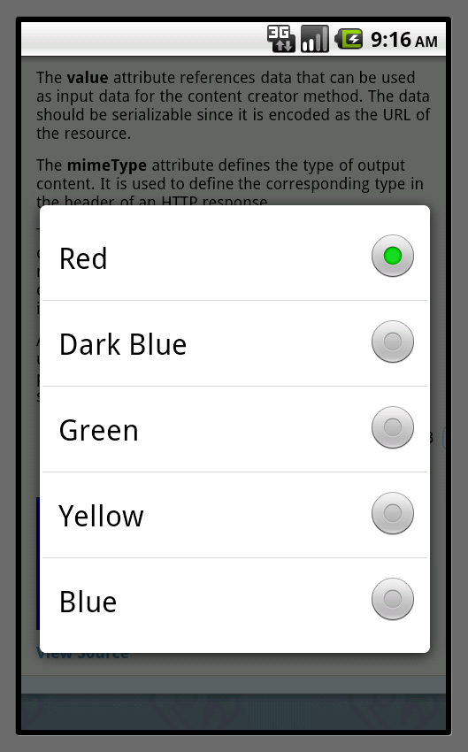

Figure 20 - Android Chrome Dropdown Option

## Date fields and use of date pickers

For date and datetime -fields the native date picker in the client browser is used. The visual look and feel of the date picker are depending on the client browser and determined by the browser vendor. Additionally, native date pickers are localized by a user’ browser setting.

Example date pickers are seen in fig (Google Chrome) and fig (Microsoft Edge) and fig (Mozilla Firefox) for desktop clients.

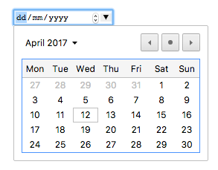

Figure 21 - Google Chrome Date Picker

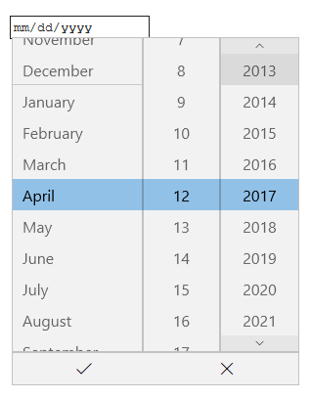

Figure 22 - Microsoft Edge Date Picker

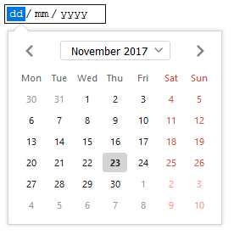

Figure 23 - Mozilla Firefox Date Picker

On mobile devices, the date pickers have a different visual look since the native behavior on mobile is different. E.g. there is no mouse pointer available on touch devices, thus the date selection is often displayed as a scrollable list.

Example date pickers are seen in fig (iOS Safari) and fig (Android Chrome).

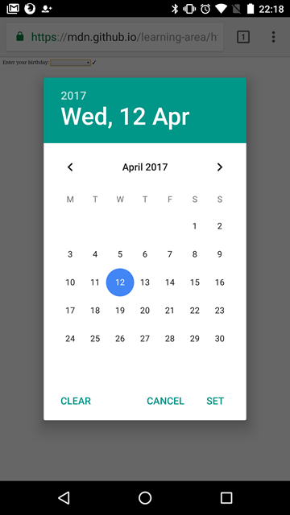

Figure 24 - Android Chrome Date Picker

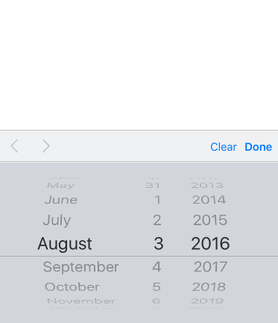

Figure 25 - iOS Safari Date Picker

# Custom Components

The NCP will include a number of reusable custom components. The following sections document the design for each of the custom components.

## Line Chart

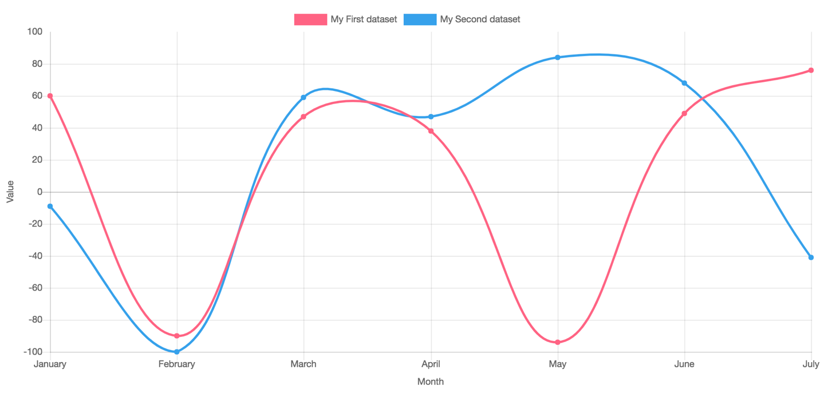

Figure 26 - Line chart

A basic line chart will be implemented. Once a line chart component has been added to a placeholder on a page, the editor will then have to select a data source in the admin dashboard statistics menu and fill out the required properties for a Chart Data Source Type.

The visitor is able to narrow the timespan along the X-axis using two datetime pickers in the top of the graph.

## Bar Chart

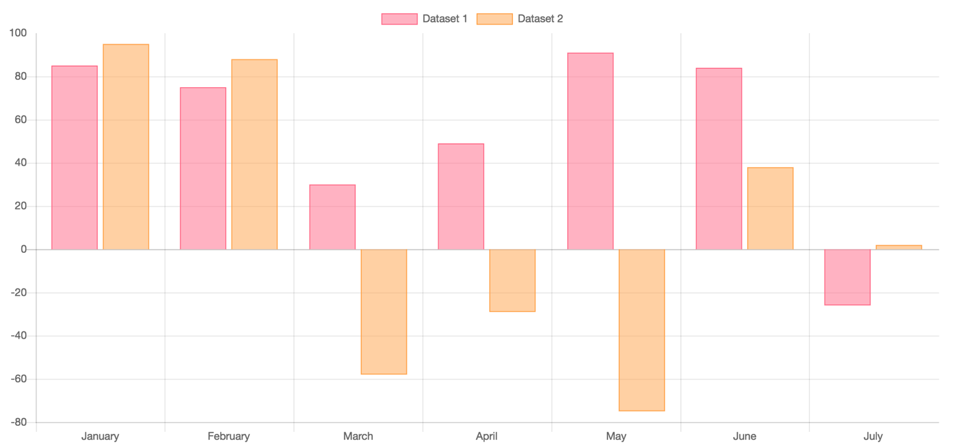

Figure 27 - Bar chart

A basic bar chart will be implemented. Once a bar chart component has been added to a placeholder on a page, the editor will then have to select a data source in the admin dashboard statistics menu, and fill out the required properties for a Chart Data Source Type. A bar chart can have both negative and positive value points on the Y-axis scale as shown in Figure 27.

When more than one datasets is plotted, the visitor will be able to toggle the label in the top of the chart to show/hide the individual bars in the chart.

## Stacked Bar Chart

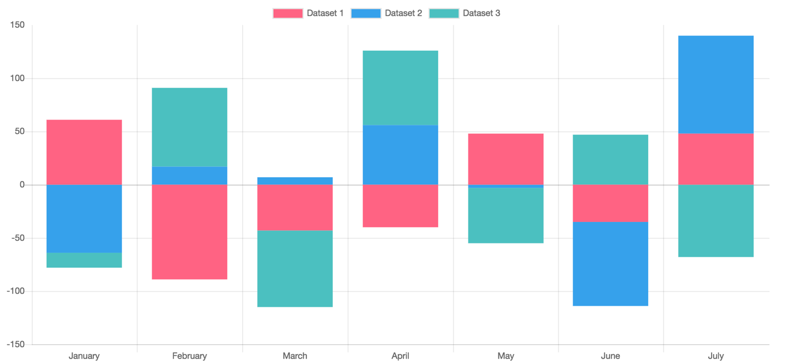

Figure 28 - Stacked Bar Chart

Similar to the basic bar chart, the stacked bar chart is able to chart both negative and positive value points on the Y-axis scales. However, when charting multiple datasets, each set will be stacked on each other as seen in Figure 28.

The visitor is able to narrow the timespan along the X-axis using two datetime pickers in the top of the graph.

## Pie Chart

#### 

Figure 29 - Pie chart

A pie chart will be implemented. Once a pie chart component has been added to a placeholder on a page, the editor will then have to select a data source in the admin dashboard statistics menu, and fill out the required properties for a Chart Data Source Type. Each slice in the pie can be toggled to hide/show by clicking the labels at the top of the graph.

The visitor is able to narrow the timespan along the X-axis using two datetime pickers in the top of the graph.

## Embedded Google Map

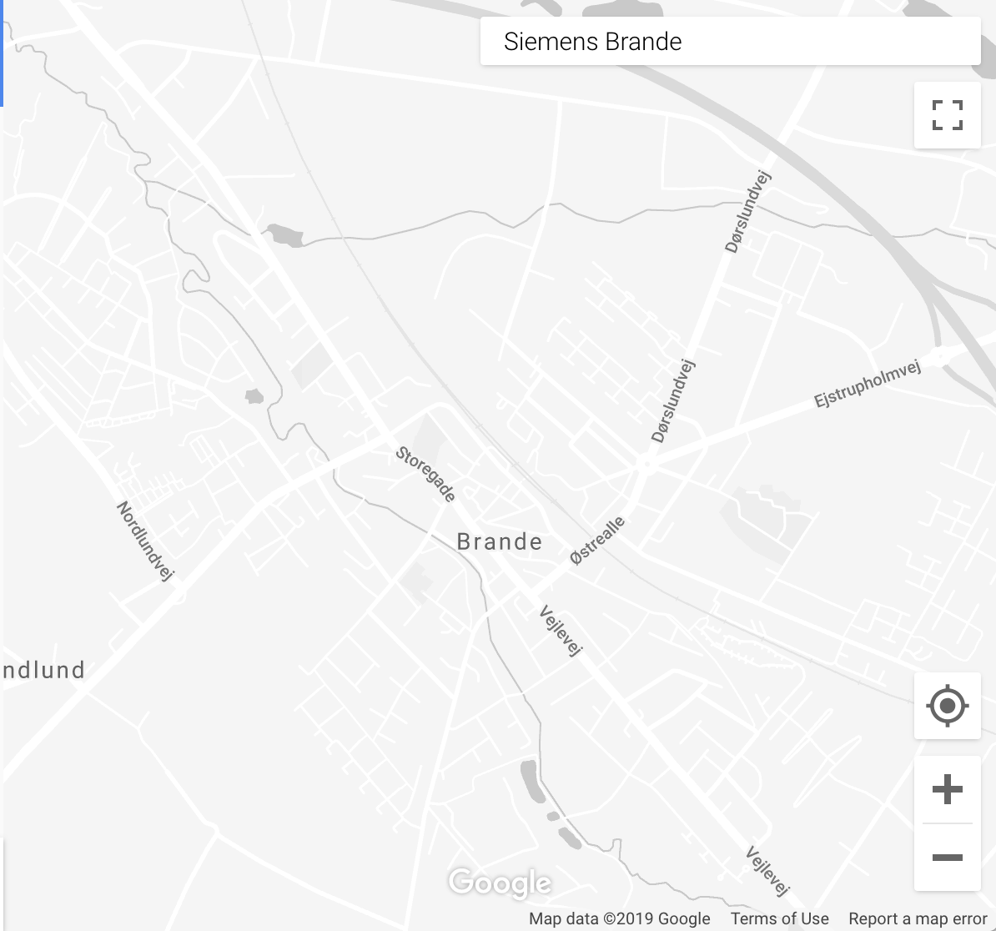

Figure 30 - Embedded Google Maps

Embedded Google maps with no styling for showing location of the upcoming event or the location of Netcompany. A screenshot of an unstyled Google Maps component is shown in Figure 30.

## Banner Alert

The banner alert component can be added to the different pages on the user interface, and comes in three different variants, all of which will be shown beneath the header on the pages where they are active. A banner can be added and targeted at a specific page of the project. This is controlled in the back-end of Sitecore.

Figure 35 shows the normal variant of the banner alert, which is simply a white box with a message and optionally a link. The component will be shown beneath the header, but will disappear as the user scrolls down on the page. On the right side of the banner is an **x**, which the user can use to dismiss the banner.



Figure 31 - Normal variant of the banner alert component

Figure 36 shows the important variant of the banner alert, which is a yellow box with a message and optionally a link, intended to draw attention. The banner will be shown beneath the header of the page , and will remain visible along with the header as the user scrolls down the page. This variant also has an **x** which can be used to dismiss the banner.



Figure 32 - Important variant of the banner alert component

Figure 37 shows the critical variant, which is red and includes an icon in order to draw attention, as well as again a message and optionally a link. This version will also be shown beneath the header, and will remain visible along with the header as the user scrolls down on a page. Unlike the other variants of the banner, this variant cannot be dismissed by the user.



Figure 33 - Critical variant of the banner alert component

## Contextual FAQ

The contextual FAQ component can be used throughout the NCP as needed, and consists of a box with a title, a description and a number of links. The title and description should be customized to the context, and the links will then link to relevant FAQ articles as judged by the individual adding the component.

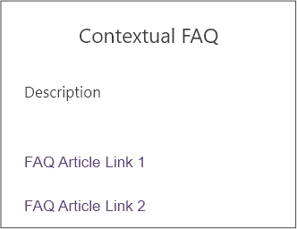

Figure 34 - Contextual FAQ component

## Dropdown Selection Component

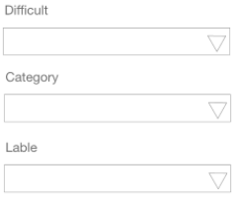

Figure 35 - Site and Turbine Dropdown Selector

The Dropdown component as seen in Figure 35 enables the customer to choose the context of information being displayed on a page (when available). Click on the dropdown and that will drop a list of context for the user to choose.

## Table Component

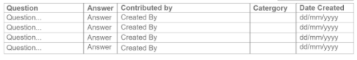

Figure 36 - Table component

The table component is a standard HTML table, however on mobile devices it can scroll horizontally when viewport is too small.

# Browser support

The application will support the following browsers and browser versions, as defined during the clarification workshops.

|  |  |  |  |  |
| --- | --- | --- | --- | --- |
| Mozilla Firefox | Google Chrome | Apple Safari | Apple Safari for IOS | Google Chrome for Android |
| 83 | 87 | 14.0.1 | 14.0 | 87 |

Figure 37 - Supported browser clients.